**University of Pittsburgh**

**Department of Electrical Engineering**

**EE/CoE 1188: Cyber-Physical Systems**

**Dr. Samuel Dickerson**

**LAB #1: DIGITAL PADLOCK**

***Intro to Microcontrollers, Assembly Language and Embedded Systems***

***DUE ON OR BEFORE FRDAY, JANUARY 20, 2017***

**PURPOSE**

The general purpose of this laboratory is to familiarize you with the software development. You will learn how to perform digital input/output on parallel ports of the MSP432. Software skills you will learn include port initialization, logic operations, and unconditional branching.

**LAB REQUIREMENTS**

For this lab, you will create is a digital lock. The lock system has two switch inputs and one LED output that represents the state of the lock. The specification for your digital lock is as follows: If no buttons are pressed, the lock is in a standby mode and displays a blue light. If both buttons are pressed simultaneously, the device is unlocked and a green light is displayed. Finally, if an incorrect button combination is entered (i.e. only one of the two buttons are depressed) a red light is displayed.

**PART A) PROJECT PREPARATION**

In this project, you will become familiar with the MSP432 hardware, and also learn how to develop software for it. This will require that you have access to the board and

1) Included on the LaunchPad development board are switches and LEDs that can be accessed by the MSP432 chipset. Specifically, on the board are two user push buttons and four LEDs. One LED emits red (LT-C 190CKT) while the other is a Tri-Color RGB LED (EL-19-337) in a 3-input surface mount package. The third pushbutton on your board (at the middle left) is used as a RESET button for the board.

1. Sketch a schematic that represents the connections between the MSP432, the two user pushbuttons, and the LEDs. Include symbols and values for all relevant components (i.e. resistors, jumpers, voltage supplies, etc.) Also, make sure you label any ports and port pin numbers. Below is a symbol for the MSP432 you can use to get started. You will need to explore to the MSP432P401R LaunchPad Development Kit User’s Guide in order to understand the layout of your board. MSP432.

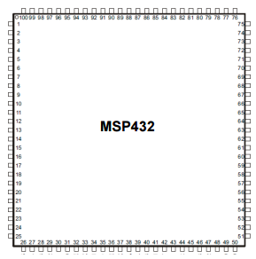

P1.0 (LED1)

P2.0 (SW1)

P1.4 (SW2)

P2.0 (RED_LED2)

P2.1 (GREEN_LED2)

P2.2 (BLUE_LED2)

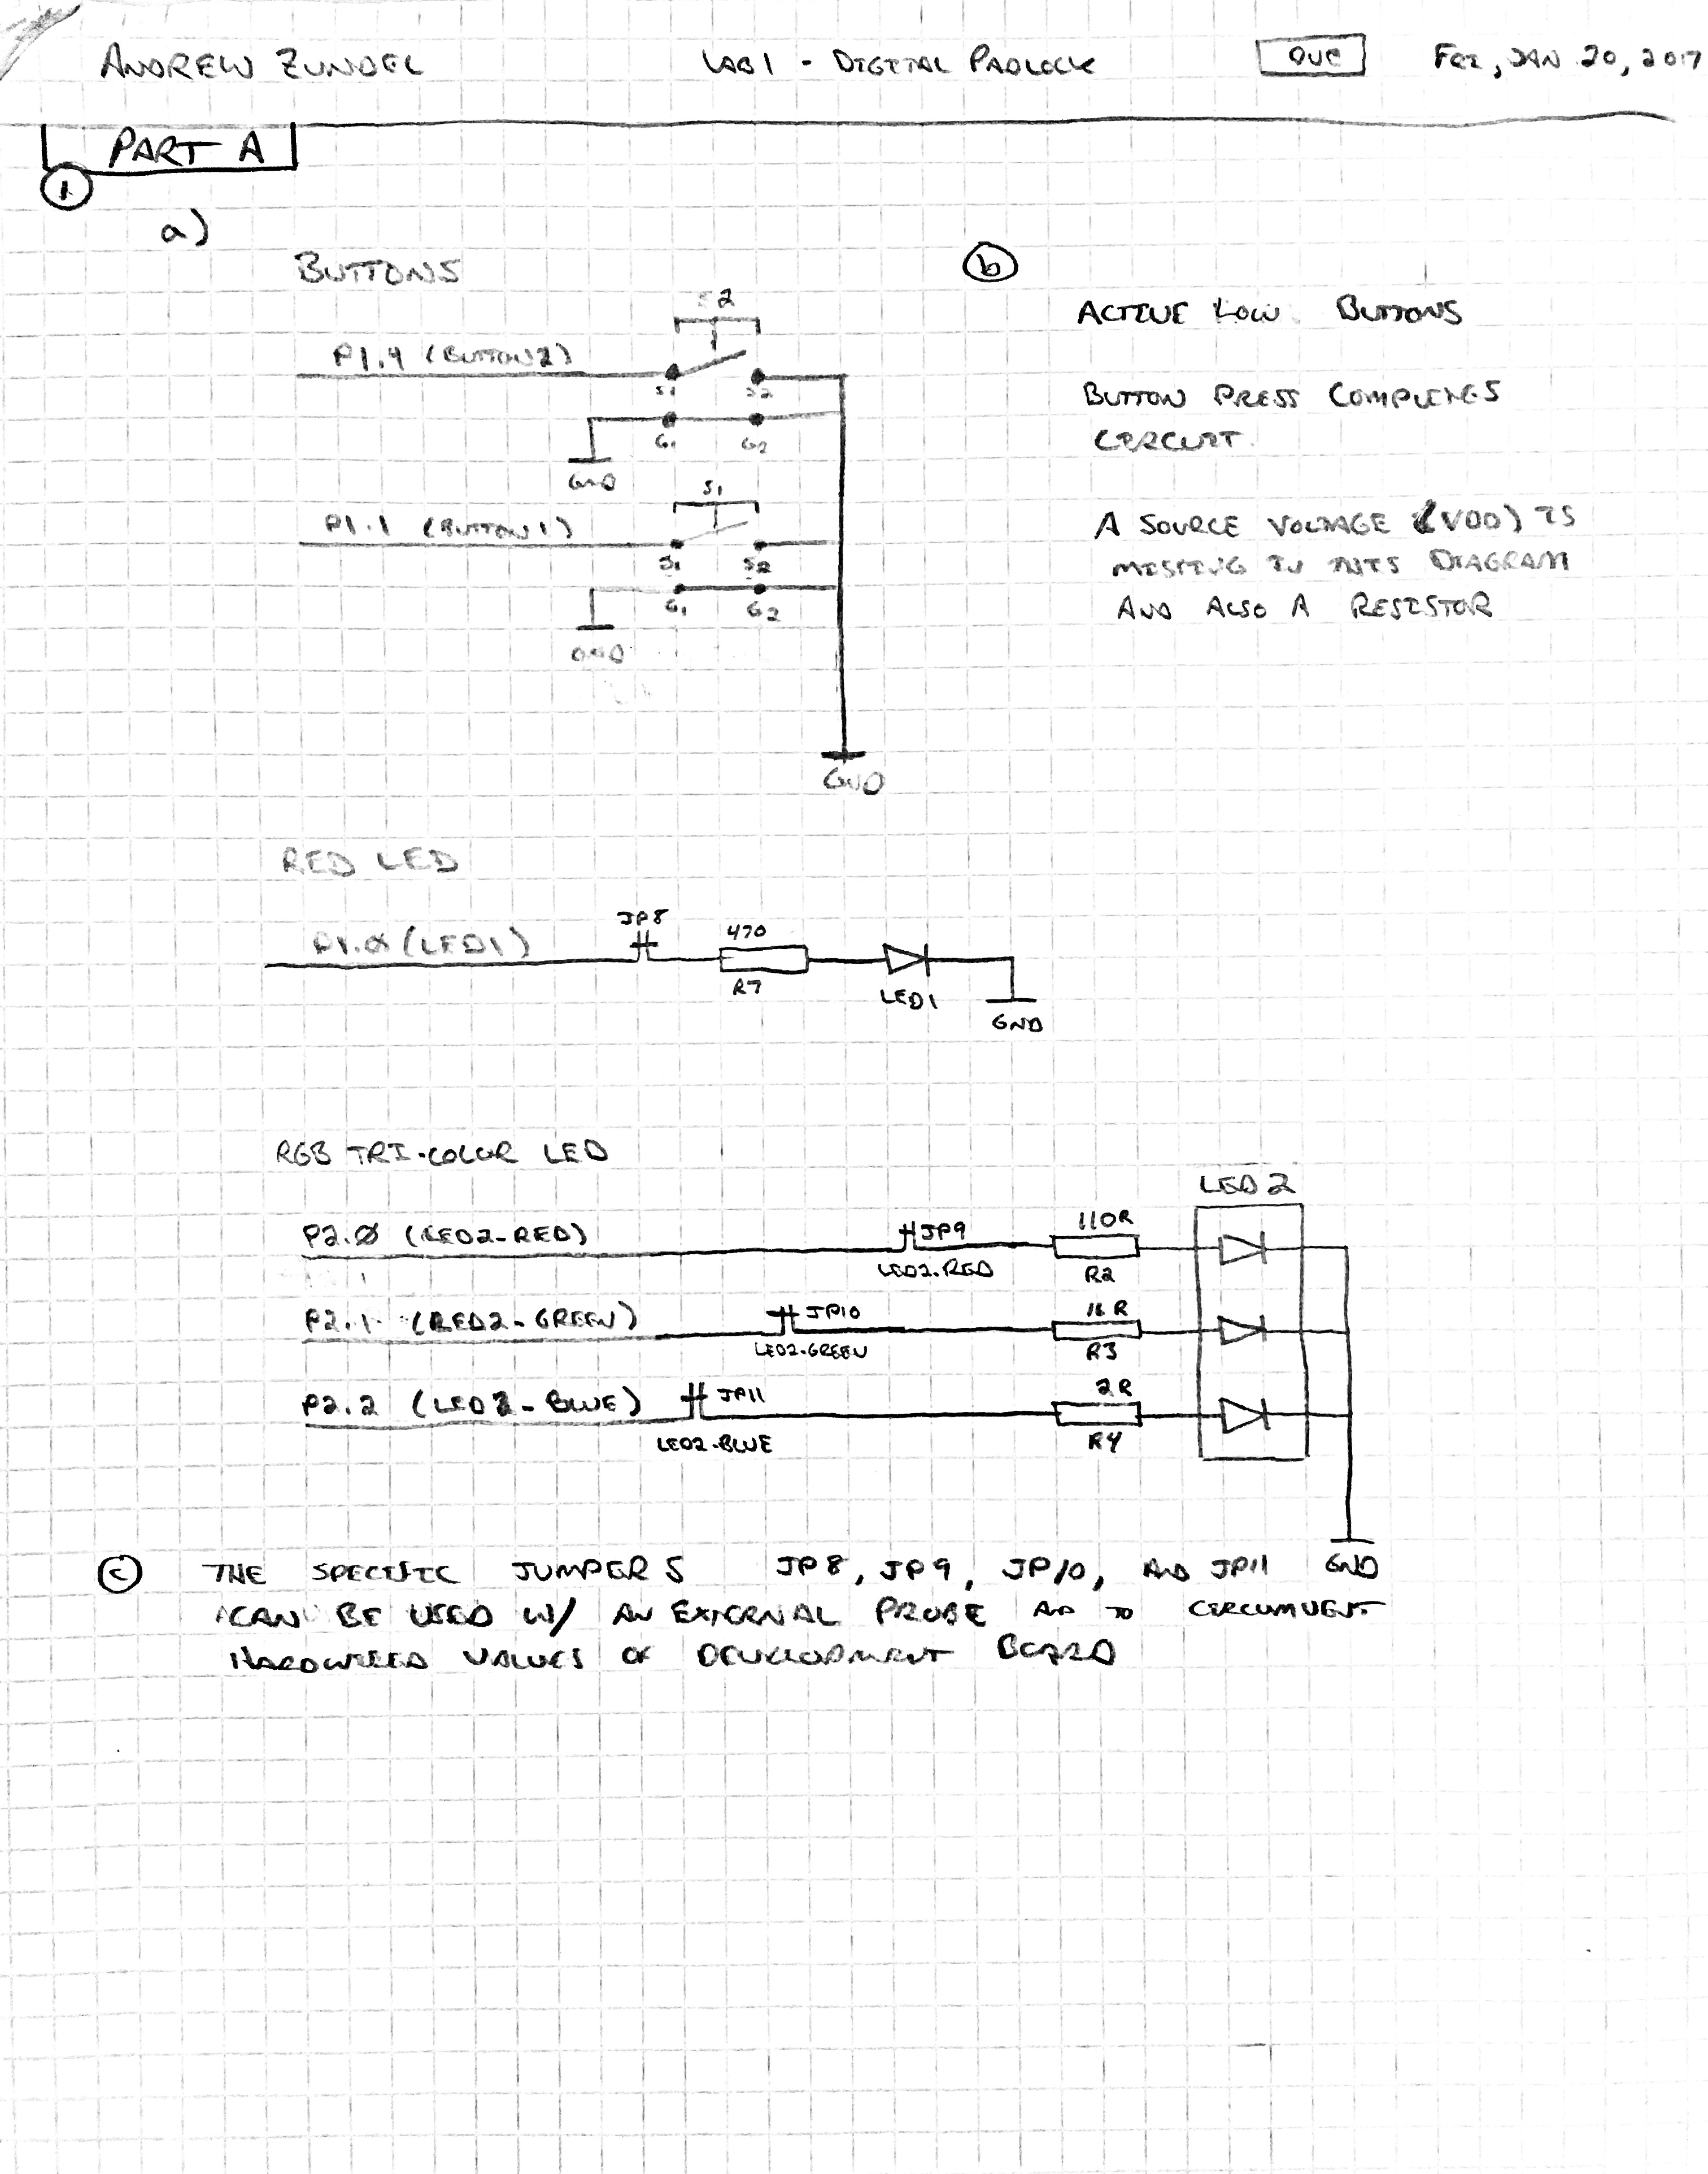

2) Find the memory map for the MSP432 in the MSP432P401R datasheet. On the MSP432, I/O ports are memory mapped just like program and data memory. This means that the software can access I/O simply by reading from or writing to the appropriate address, as if it were just another memory location.



**PART B) PSEUDO CODE**

Write pseudo code for this program. You may use any syntax you wish, but the algorithm should be clear.



**SOURCE CODE**

.thumb

**.text**

**.align** 2

**.global** main

.thumbfunc main

**main:** .asmfunc

; Base Address of Port Mappings

**MOV** R0, #0x4c00

MOVT R0, #0x4000

;Settings for Port 1 [000S00SL]

**MOV** R1, #0xFE ; 2 1

**MOV** R2, #0x00

STRB R2, [R0, #0x04] ; P1DIR => [00000000] = 0 (Input Mode for SWITCHes)

STRB R1, [R0, #0x06] ; P1REN => [00010010] = 1 (Registers for each SWITCH and LED)

STRB R2, [R0, #0x08] ; P1SEL0 => [00000000] = 0 --> General Purpose Register Option

STRB R2, [R0, #0x0A] ; P1SEL1 => [00000000] = 0 -/

;Settings for Port 2 [00000BGR]

**MOV** R1, #0x07

**MOV** R2, #0x00

STRB R1, [R0, #0x05] ; P2DIR => [00000111] = 1 (Output Mode For LEDs)

STRB R1, [R0, #0x07] ; P2REN => [00000111] = 1 (Registers for each position of LED)

STRB R2, [R0, #0x0B] ; P2SEL0 => [00000000] = 0 --> General Purpose Register Option

STRB R2, [R0, #0x0D] ; P2SEL1 => [00000000] = 0 -/

; Initialize P2OUT to Display BLUE LED

**MOV** R1, #0x04 ; [00000100] B__

STRB R1, [R0, #0x03] ; P2OUT => 0x40004C03

running ; Start main loop of padlock program

; Check both input switches

LDRB R7, [R0, #0x00] ; P1IN => 0x40004C00

**AND** R7, R7, #0x12

; If R7 contains 0x12 no SWITCH is pressed

**MOV** R6, #0x00

**SUB** R6, R7, #0x12

CBZ R6, blue

; If R7 contains 0x10 SWITCH 2 is being pressed

**MOV** R6, #0x00

**SUB** R6, R7, #0x10

CBZ R6, red

; If R7 contains 0x02 SWITCH 1 is being pressed

**MOV** R6, #0x00

**SUB** R6, R7, #0x02

CBZ R6, red

; If R7 contains 0x00 Both SWITCHes are pressed

CBZ R7, green

blue

**MOV** R5, #0x04 ; [00000100] B__

STRB R5, [R0, #0x03] ; P2OUT => 0x40004C03

**B** running

green

**MOV** R5, #0x02 ; [00000010] _G_

STRB R5, [R0, #0x03] ; P2OUT => 0x40004C03

**B** running

red

**MOV** R5, #0x01 ; [00000001] __R

STRB R5, [R0, #0x03] ; P2OUT => 0x40004C03

**B** running

.end